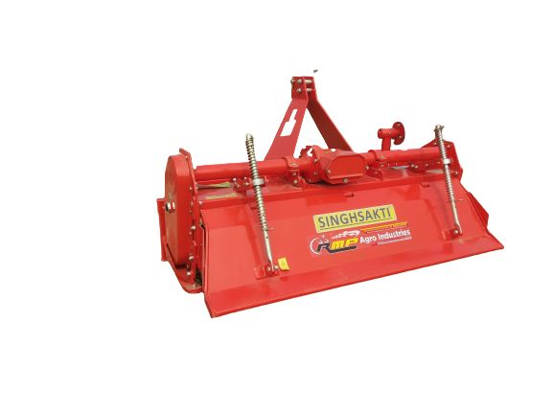 Gyrovator ZLX

Singhsakti ZLX Gyrovator is a tractor mounted and PTO operated implement which does 3 operations at a time.i.e. cutting, mixing and levelling of soil. The Singhsakti ZLX Gyrovator is equipped with Multi Speed Drive & it offers wider range of rotor speed ratios.

FEATURES

* Leveled surface with the gyrovator enables better fuel efficiency.
* Multi speed adjustor for various applications.

* It has features like Multi depth adjustment, Duo cone mechanical water tight seal which is best suitable for dry and wet land applications.
* Ensures excellent cutting and mixing of stubbles and better mixing of manure. Crushes the clods into fine particles i.e. better tilth.

* The ZLX Gyrovator has Helicoidal anti wear blades with suitable blade type(C,L,J) for better cut.
* Effective for puddling due to better churning of soil and less slippage as compared to puddler/ disk harrow.

* Internationally designed range for noise free easy working.

Specification

|  |  |  |  |  |  |
| --- | --- | --- | --- | --- | --- |
|  | **Singhsakti ZLX 125** | **Singhsakti ZLX 145** | **Singhsakti ZLX 165** | **Singhsakti ZLX 185** | **Singhsakti ZLX 205** |
| Working width in (m) | 1.25 | 1.45 | 1.65 | 1.85 | 2.05 |
| Tractor kW (HP) required | 22.4-44.7 kW (30-60 HP) | 26.1-44.7 kW (35-60 HP) | 29.8-44.7 kW (40-60 HP) | 33.6-44.7 kW (45-60 HP) | 41-44.7 kW (55-60 HP) |
| Tractor PTO (RPM) | 540 r/min | 540 r/min | 540 r/min | 540 r/min | 540 r/min |
| No of blades | 36 | 42 | 48 | 54 | 60 |
| Type of blade | L | L | L | L | L |
| Transmission | Gear Drive | Gear Drive | Gear Drive | Gear Drive | Gear Drive |
| Gear Box | Multi Speed: 4 speed standard | Multi Speed: 4 speed standard | Multi Speed: 4 speed standard | Multi Speed: 4 speed standard | Multi Speed: 4 speed standard |

* After harvesting rice/paddy, it churns the remains of the crop to increase the humus.

* The Singhsakti ZLX Gyrovator is equipped with Multi Speed Drive & it offers wider range of rotor speed ratios. Rotor speed can be varied as per the tilth quality required and the soil condition available.

#### **SPECIFICATIONS**

#### **BENEFITS WITH MAHINDRA TRACTOR**